**Narrative Report**

Name: **Mark Kevin C. Regio**

Program & Course: **DICT – 3**

**I. Introduction**

At the Governor Helen Tan Covered Court, PUP Mulanay Branch, on June 16, 2023, from 8:00 AM to 5:00 PM for the Series 2 OJT Career Development event titled "Alignment of Students' Career Path Line from Theories to Practice." This transformative gathering aims to bridge the gap between theoretical knowledge and practical application, offering aspiring professional’s valuable insights and hands-on experiences. Engage with industry experts, seasoned professionals, and esteemed speakers, participate in workshops, interactive sessions, and panel discussions, and explore the seamless integration of theories and practices in various fields. Come and empower the next generation of professionals as we foster an atmosphere of collaboration and equip students with the tools needed to excel in their chosen careers.

**II. Narration of Events:**

The Series 2 OJT Career Development event unfolds with a solemn prayer and the stirring rendition of the national anthem, setting the stage for a day of growth and inspiration. Ms. Huryettha D. Marasigan, our OJT and QA Coordinator, extends a warm welcome to all participants, fueling the atmosphere with excitement and anticipation. Dr. Michael R. Babao, the first speaker, delves into the "Exploration on Student Career Development," offering valuable insights and guidance to navigate the vast realm of career choices. Asst. Prof. Gilberto L. Olicia follows, emphasizing the importance of critical thinking and problem-solving for career development. Asst. Prof. Abel L. Pelandiana sheds light on leveraging information communication technology (ICT) for career growth, while Dr. Noel Lenerd J. Robledo shares his experiences in mentoring and learning. Ms. Ma. Leila R. Aguila inspires us with her stories of volunteer work and development research. And, the certificates of every speaker after the discussion of their topic. The event culminates with heartfelt closing remarks by HJelmar M. Abulencia, leaving us with gratitude and renewed determination to apply the knowledge gained on our career journeys.

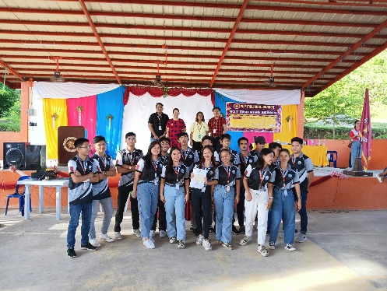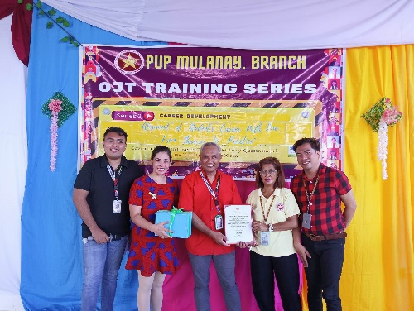

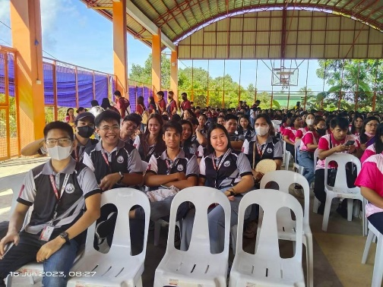

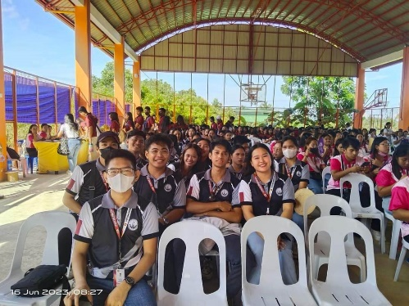

**Knowledge / Learning Acquired:**

Durind the seminar in series 2 OJT Career development I gained a deep understanding of the exploration of student career development, guided by Dr. Michael R. Babao. Asst. Prof. Gilberto L. Olicia equipped them with critical thinking and problem-solving skills crucial for career advancement. The insights shared by Asst. Prof. Abel L. Pelandiana regarding information communication technology (ICT) opened new avenues for professional growth. Dr. Noel Lenerd J. Robledo's experiences in mentoring and learning provided a wealth of guidance, while Ms. Ma. Leila R. Aguila's stories of volunteer work and development research inspired them to make a positive impact. Armed with this newfound knowledge, participants departed the event with a heightened sense of readiness and determination to navigate their career paths successfully.

**III. Recommendations / Learning Suggestions:**

I would like to thanks to the seminar organizers and convey my sincere appreciation for the invaluable information shared. As an OJT student, I am filled with confidence knowing that the knowledge I have acquired, as well as that of my fellow participants, will greatly benefit us in our forthcoming experiences.